The Nautilus DevOps team has been tasked with creating an internal information portal for public access. As part of this project, they need to host a static website on AWS using an S3 bucket. The S3 bucket must be configured for public access to allow external users to access the static website directly via the S3 website URL.
Task Requirements:
- Create an S3 bucket named datacenter-web-10084.
- Configure the S3 bucket for static website hosting with index.html as the index document.
- Allow public access to the bucket so that the website is publicly accessible.
- Upload the index.html file from the /root/ directory of the AWS client host to the S3 bucket.
- Verify that the website is accessible directly through the S3 website URL.

Use below given AWS Credentials: (You can run the showcreds command on aws-client host to retrieve these credentials)
Console URL | https://613837775091.signin.aws.amazon.com/console?region=us-east-1
Username | kk_labs_user_260835
Password | 1nhW4e6O4^!B
Start Time | Tue Jan 13 05:45:39 UTC 2026
End Time | Tue Jan 13 06:45:39 UTC 2026
Notes:
- Create the resources only in us-east-1 region.
- To display or hide the terminal of the AWS client machine, you can use the expand toggle button as shown below:

Solutions:-
📂 Console Navigation for S3 Website Hosting
Once logged in:
- Go to Services → S3.
- Create the bucket: datacenter-web-10084.
- Click on the bucket name to open its details.
Configure Website Hosting
- In the Properties tab → scroll to Static website hosting.
- Enable it and set:
  - Index document: index.html
Public Access Settings
- In the Permissions tab:
  - Disable Block Public Access.
  - 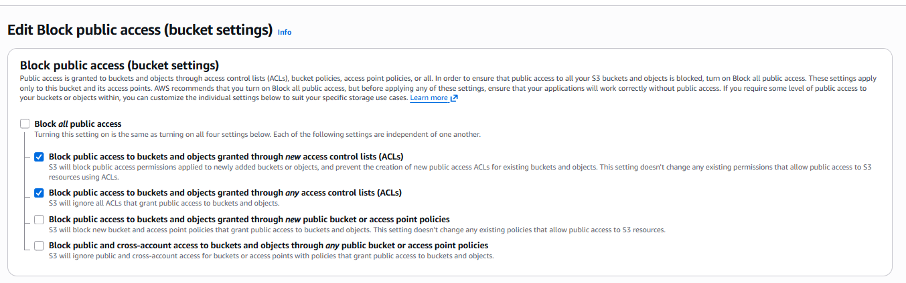
  - Add a Bucket Policy with public read access .
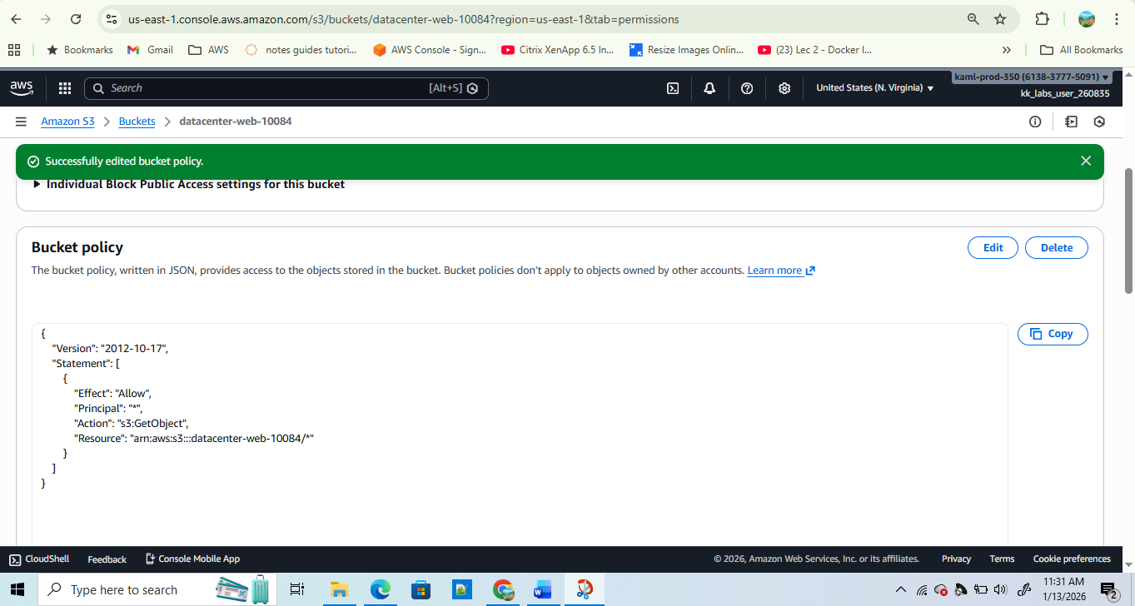

Upload Files
- Upload the index.html file from /root/:
- aws s3 cp /root/index.html s3://datacenter-web-10084/
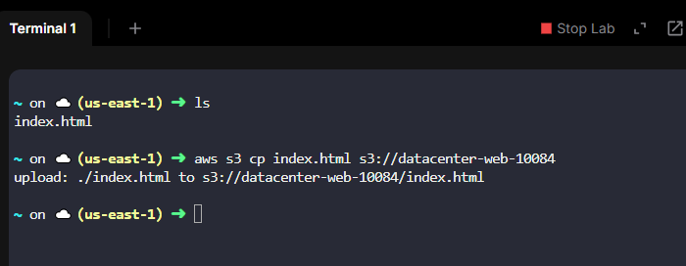

Verify Website URL
The S3 static website URL format is:

Open this in your browser — you should see the contents of index.html.
